Create Node-RED Service

|  |  |
| --- | --- |
| **Date** | **21-10-2022** |
| **Team ID** | **PNT2022TMID17666** |
| **Project Name** | **IOT based safety gadget for**  **child safety monitoring and notification** |
| **Maximum Marks** | **4 Marks** |
| **Submitted By** | **Priya.V**  **Vasunthara.D**  **Janani Ishwarya.S**  **Janani.R** |

Aim: To create a web applications create a Node-RED service.Steps followed:

* Navigated to the App creation page

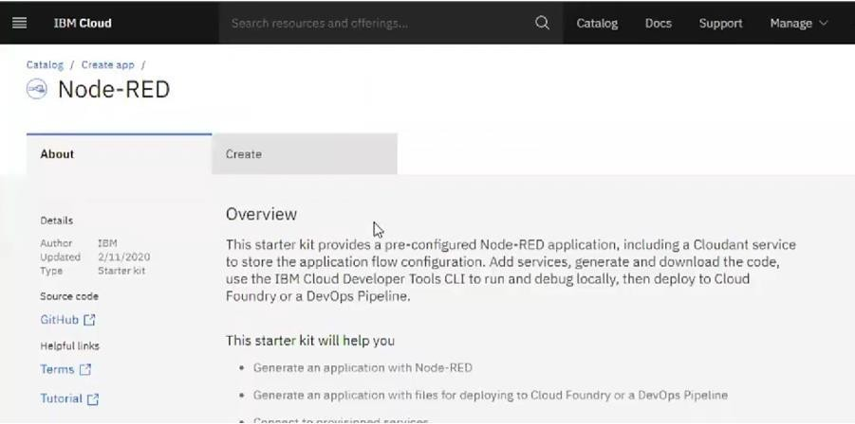

* + Entered project details and clicked on create

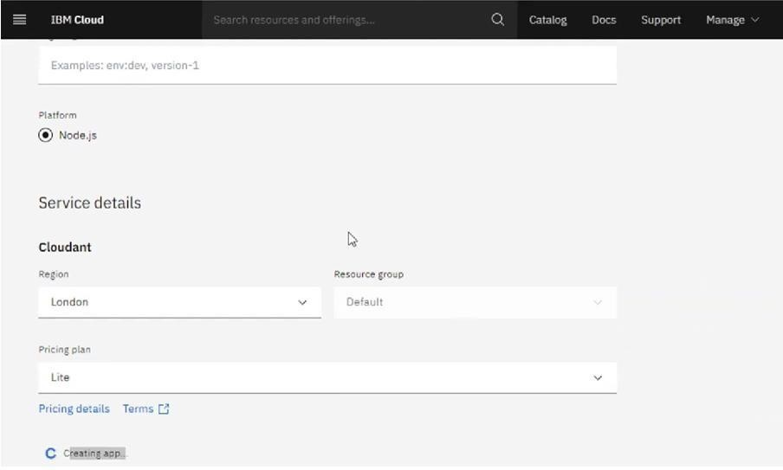

* Clicking on the “Deploy your App” Button

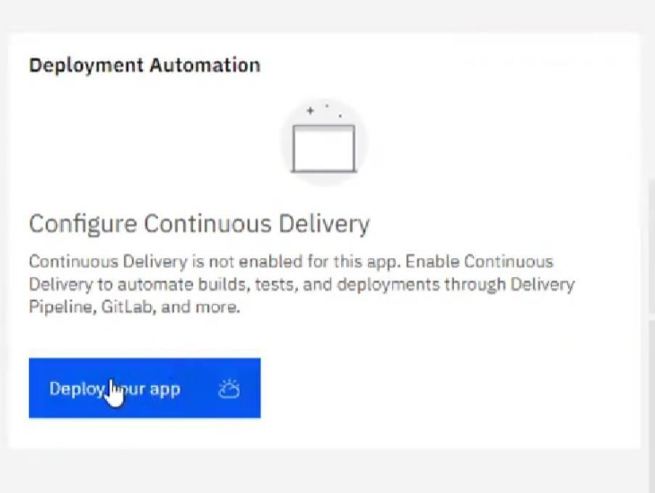

* Setting up the environment and deploying the app

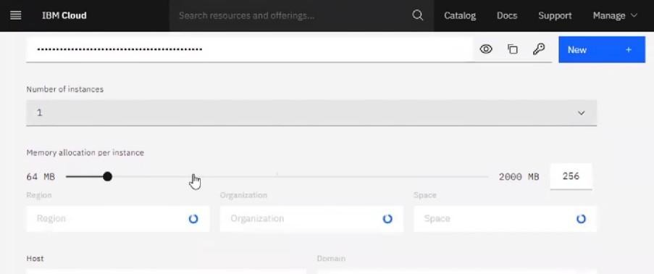

* Successfully deployed the app

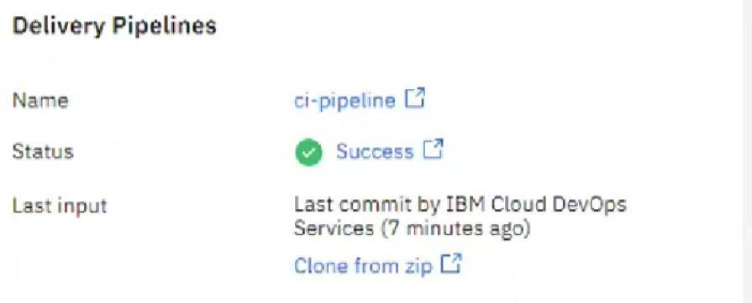

* Dragged and dropped components into the editor

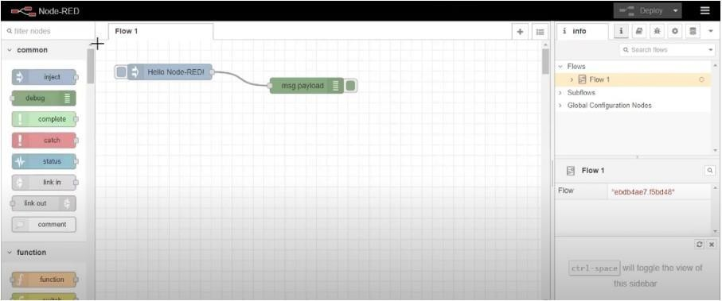

* Editing some values of the properties

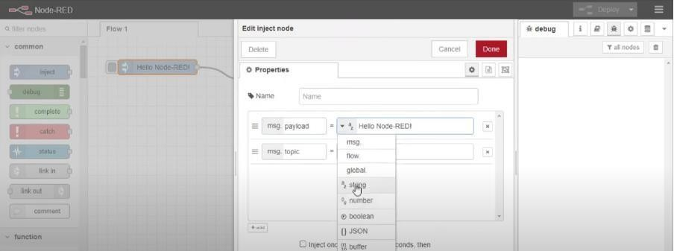

* Successfully deployed the app

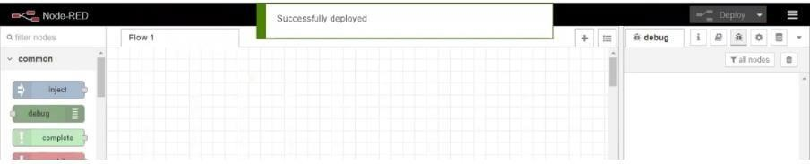

**Result: Successfully created a NodeRED service on IBM Cloud**